M3H U4 Day 10 HW – Partial Fractions
Show all your work to decompose the rational function into it’s partial fractions.

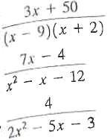
1.

2.

3.
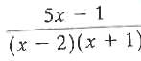
4.

5. $\frac{9x-4}{(x-3)(x+5)}$

6.$\frac{x}{(x-3)(x-2)}$

7.$\frac{1}{x(x-1)}$

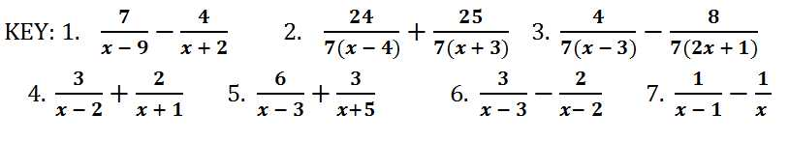
8(x+5)
8(x-3)
49
23

