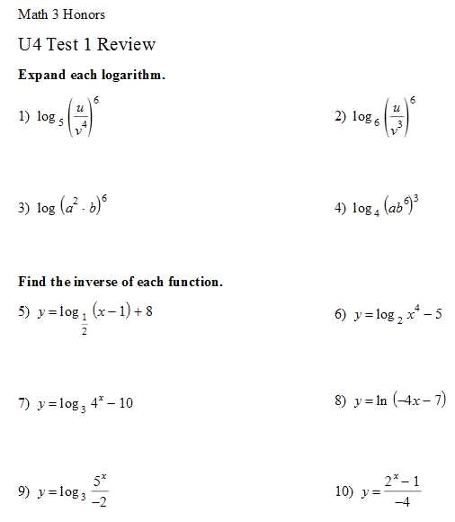
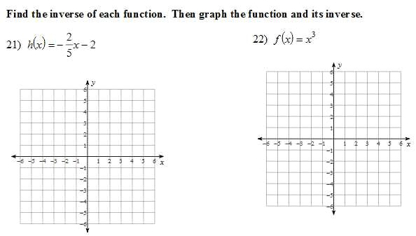

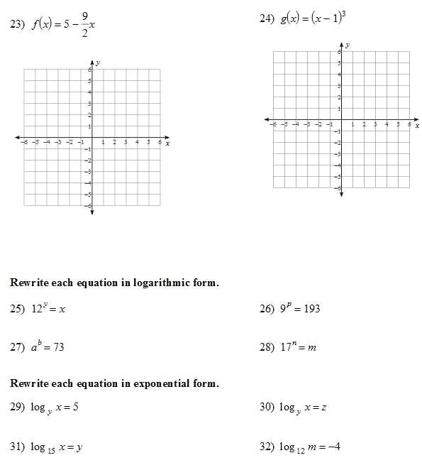

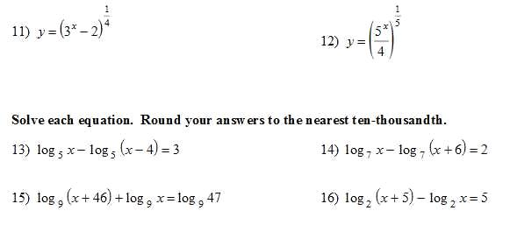

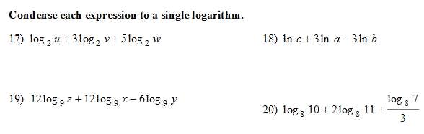

Find the inverse algebraically. Restrict the domain if the function is not one-to-one. Complete the table.
$$f\left(x\right)=2{(x+5)}^{3}-3$$ | $$f\left(x\right)=2{(x+5)}^{3}-3$$ | $$f^{-1}\left(x\right)=$$
D: |  | D:
: |  | R:

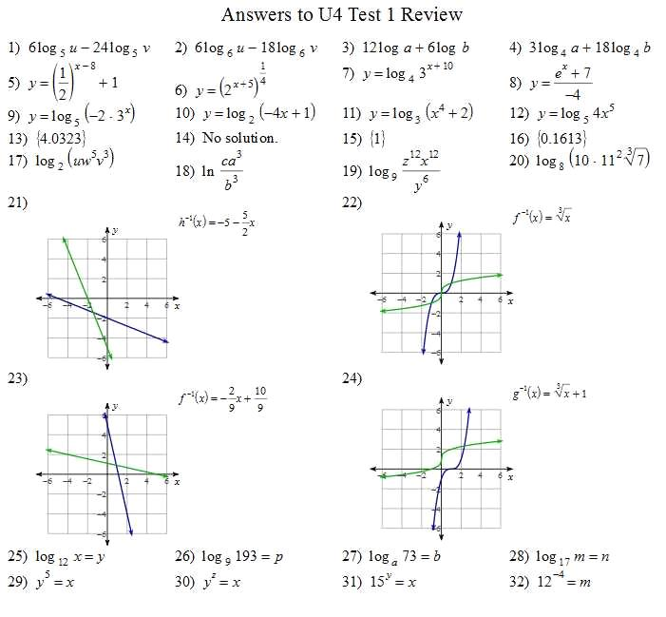
33. f(x): D: (-∞, ∞) R: (-∞, ∞)
f⁻¹(x) = $\sqrt[3]{\frac{x+3}{2}}-5$
D: (-∞, ∞) R: (-∞, ∞)

