M3H U3 Day 4 Mixed Review and Complex Fractions HW
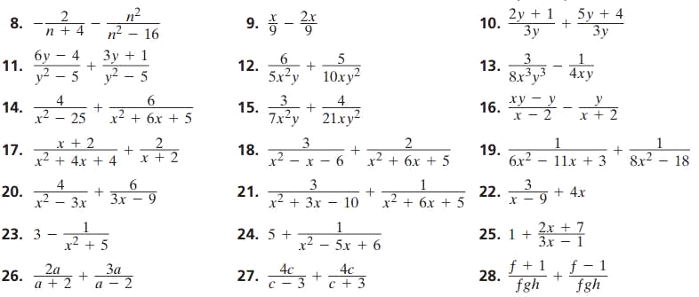
#9 – 27 ODDS, #32, 33, 34, 38 ALL on LINED PAPER. Check all your work with the A2 WB KEY.

