Station 1:

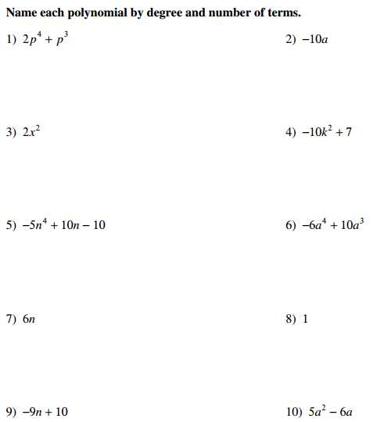

Station 1:

Station 2:

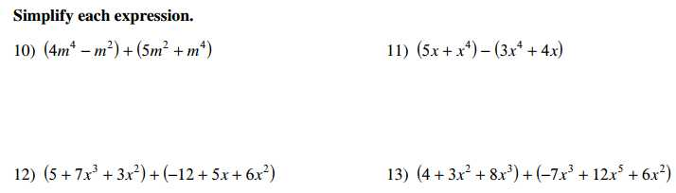

Station 2:

Station 3:

Multiply each polynomial
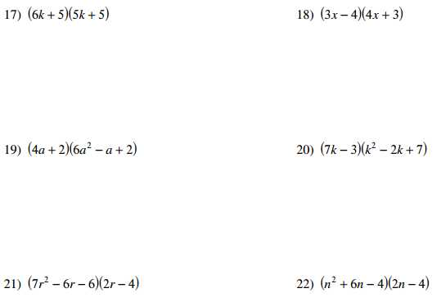

Station 3:

Multiply each polynomial

Station 4:

Multiply each polynomial

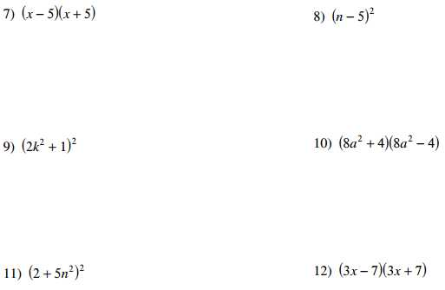

Station 4:

Multiply each polynomial

Station 5:

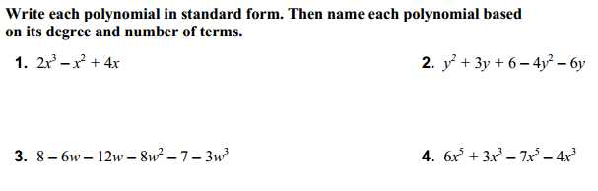

Station 5:

Station 5:

