Day 6 Notes
Remainder Theorem
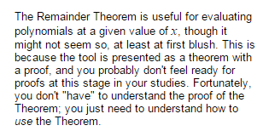
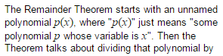
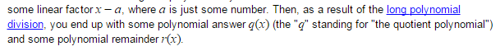

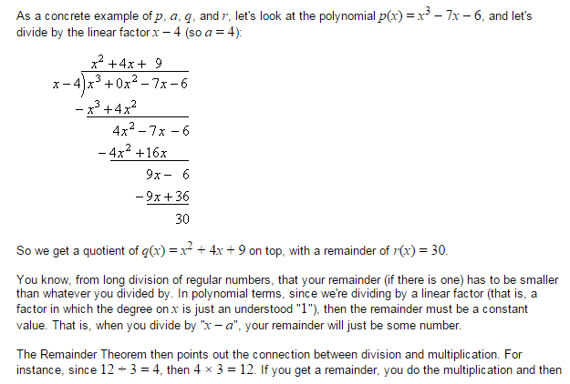
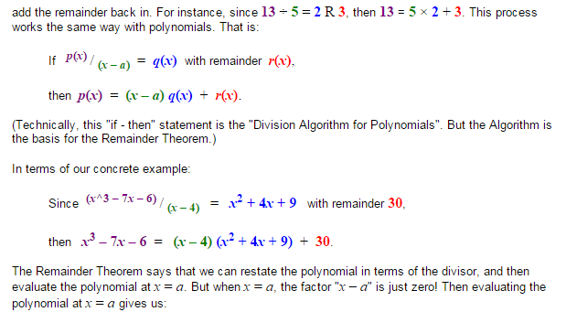
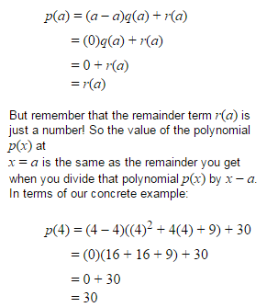
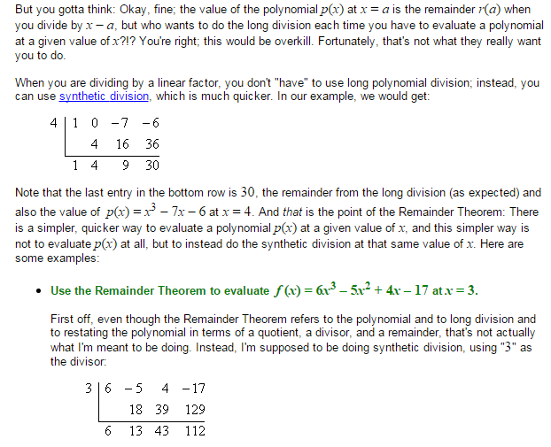
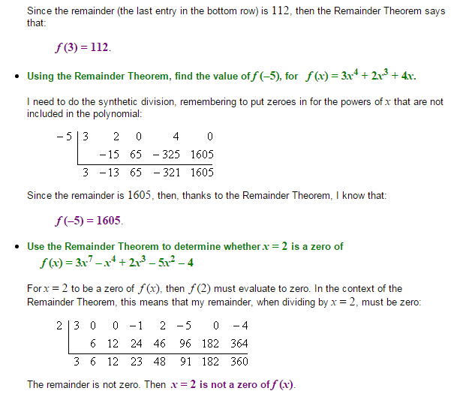
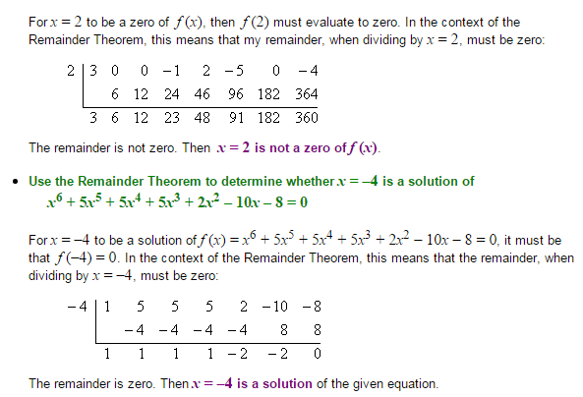
https://www.khanacademy.org/math/algebra2/arithmetic-with-polynomials/polynomial-remainder-theorem/v/polynomial-remainder-theorem

http://www.wtamu.edu/academic/anns/mps/math/mathlab/col_algebra/col_alg_tut37_syndiv.htm

