Sine and Cosine Parent Functions

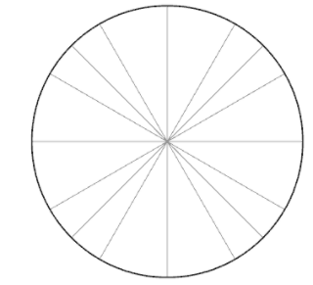

|  |  |
| --- | --- |
| Ө | cos Ө |
|  |  |
|  |  |
|  |  |
|  |  |
|  |  |

|  |  |
| --- | --- |
| Ө | Sin Ө |
|  |  |
|  |  |
|  |  |
|  |  |
|  |  |

